# Overview

To become familiar with Object-Oriented Synergy.

# Resources

* [Synergy DBL Language Reference](https://www.synergex.com/docs/index.htm)
* [System-Supplied Classes](https://www.synergex.com/docs/versions/v111/index.htm#lrm/10_System_Classes.htm)
* [Understanding Objects and Classes](https://www.synergex.com/docs/versions/v111/index.htm#lrm/8_Classes.htm)
* [Synergy Best Practices - Coding Standards](http://jobfunc2.cu.net/Job%20Functions/Programmer/Programmer%20Handbook/Tims%20Best%20Practices%20-%20Standards/Synergy%20Best%20Practices%20-%20Coding%20Standards.docx)
* [Traditional Synergy in Visual Studio - CU Wiki](http://echo.cu.net/cuwiki/Traditional_Synergy_in_Visual_Studio)
* [Traditional Synergy in Visual Studio Common Terminology - CU Wiki](http://echo.cu.net/cuwiki/Traditional_Synergy_in_Visual_Studio_Common_Terminology)
* [Installing Traditional Synergy in Visual Studio Templates - CU Wiki](http://echo.cu.net/cuwiki/Installing_Traditional_Synergy_in_Visual_Studio_Templates)
* [Creating a New ELB Project (TSVS) - CU Wiki](http://echo.cu.net/cuwiki/Creating_a_New_ELB_Project_(TSVS))
* [Debugging (TSVS) - CU Wiki](http://echo.cu.net/cuwiki/Debugging_(TSVS))

# Exercise

For this exercise you should complete the following steps in the order shown:

1. Create a “Training” folder under the “Synergy” folder of your local source tree.
2. Create an “OOSynergy” folder under the “Training” folder.
3. Open Synergy\TIMS.ELBs.sln.
4. Add a new [CU – Executable Library (ELB)](http://echo.cu.net/cuwiki/Creating_a_New_ELB_Project_(TSVS)) project “AnimalClassLibrary” in “\Synergy\Training\OOSynergy”.

**Note:**  You will need to search for “Computers Unlimited” in the “Add a new project” dialog:

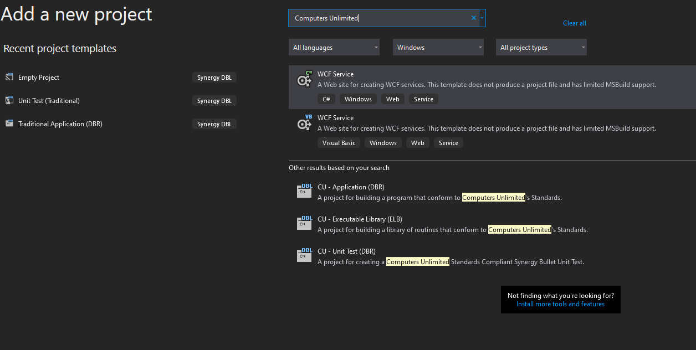

1. Due to current limitations in Visual Studio, the name of the project will always be Program. To work around this you need to select the project and Hit F2to rename the project.
2. Rename the project to “AnimalClassLibrary”.
3. You can ignore, and/or remove the generated “Headers.dbv” file.
4. Now open the Project Properties (Hotkey Alt+Enter).
5. Change the Output name under the Application Tab to “AnimalClassLibrary”.
6. Add a reference to “tklib.elb” to the “AnimalClassLibrary” project:

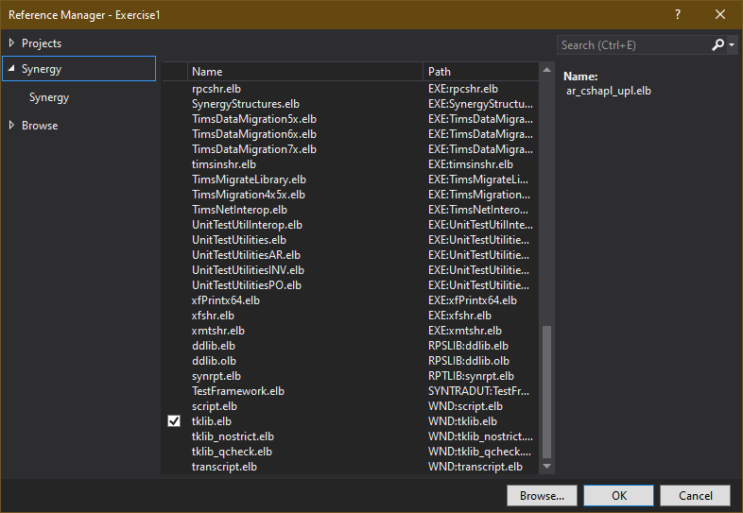

1. Open “Properties” of “tklib.elb” and set “Copy Local” to “True”:

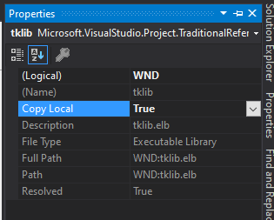

1. Add a “Projects” reference for:
   * “ComputersUnlimited.Utilities”
   * “DataAccessLibrary”
   * “Repository”
   * “SynergyStructures”
2. Copy the following files from the [AnimalClassLibrary](http://jobfunc2.cu.net/Job%20Functions/Forms/AllItems.aspx?RootFolder=%2FJob%20Functions%2FProgrammer%2FProgrammer%20Handbook%2FSynergy%20Training%20%2D%20OO%20Synergy%2FAnimalClassLibrary&FolderCTID=0x012000FC5F7830AB3285468F1BB93F0E3B999A&View=%7B7508F81D%2DB9E4%2D493C%2DB51B%2D6EAE9F530F0D%7D) folder to your local “\AnimalClassLibrary\Program” file and add them to the AnimalClassLibrary project:
   * [Pigs.txt](http://jobfunc2.cu.net/Job%20Functions/Programmer/Programmer%20Handbook/Synergy%20Training%20-%20OO%20Synergy/AnimalClassLibrary/Pigs.txt)
   * [Enumerations.dbl](http://jobfunc2.cu.net/Job%20Functions/Programmer/Programmer%20Handbook/Synergy%20Training%20-%20OO%20Synergy/AnimalClassLibrary/Enumerations.dbl)
   * [Pig.dbl](http://jobfunc2.cu.net/Job%20Functions/Programmer/Programmer%20Handbook/Synergy%20Training%20-%20OO%20Synergy/AnimalClassLibrary/Pig.dbl)
   * [PigMapper.dbl](http://jobfunc2.cu.net/Job%20Functions/Programmer/Programmer%20Handbook/Synergy%20Training%20-%20OO%20Synergy/AnimalClassLibrary/PigMapper.dbl)
     + Update PIG_DATA_FILE to be the full file path to “Pig.txt”.
3. Create a new “UnitTests” folder in “..\Synergy\Training\OOSynergy\AnimalClassLibrary”.
4. Add a new [CU – Unit Test (DBR)](http://echo.cu.net/cuwiki/Creating_a_New_Unit_Test_Project_(TSVS)) project “PigTests” in “\Synergy\Training\OOSynergy\AnimalClassLibrary\UnitTests”.
5. Rename the generated UnitTests.dbv file to “PigTests.dbv”.
6. Now open the Project Properties (Hotkey Alt+Enter).
7. Set “PigTests” as the startup project.
8. Add a reference to “tklib.elb” to the “PigTests” project:
   * Open “Properties” of “tklib.elb” and set “Copy Local” to “True”.
9. Add a “Projects” reference for:
   * “AnimalClassLibrary”
   * “ComputersUnlimited.Utilities”
   * “DataAccessLibrary”
   * “Repository”
   * “SynergyStructures”
   * “UnitTestsFrameworkLibrary”
   * “UnitTestUtilitiesLibrary”
10. Copy the **contents** of [PigTest.dbv](http://jobfunc2.cu.net/Job%20Functions/Programmer/Programmer%20Handbook/Synergy%20Training%20-%20OO%20Synergy/AnimalClassLibrary/PigTests.dbv) from the [AnimalClassLibrary](http://jobfunc2.cu.net/Job%20Functions/Forms/AllItems.aspx?RootFolder=%2FJob%20Functions%2FProgrammer%2FProgrammer%20Handbook%2FSynergy%20Training%20%2D%20OO%20Synergy%2FAnimalClassLibrary&FolderCTID=0x012000FC5F7830AB3285468F1BB93F0E3B999A&View=%7B7508F81D%2DB9E4%2D493C%2DB51B%2D6EAE9F530F0D%7D) folder to your local “\AnimalClassLibrary\UnitTests\PigTests\PigTests.dbv”.
11. Create a Hen class, using [Pig.dbl](http://jobfunc2.cu.net/Job%20Functions/Programmer/Programmer%20Handbook/Synergy%20Training%20-%20OO%20Synergy/AnimalClassLibrary/Pig.dbl) as an example:
    * Property Name (string) get/set
    * Property Age (int) get
    * Property BirthDate (@DateTime) get/set
    * Property ExpirationDate (@DateTime) get/set
    * Property Weight (decimal) get/set
    * Property Organic (boolean) get/set
    * Property Breed (ChickenBreed enum) get/set
    * Property UnitPrice (decimal) get/set
    * Property RetailPrice (decimal) get
      + Retail Price is calculated as follows:
        - UnitPrice * Weight
        - Plus age premium: $1.00 if < 1 year, $0.75 if 1-2 years.
        - Plus organic premium: $2.00 if organic
        - Expired discount: If expired then Retail Price is 10% of its calculated price.
12. Create a ChickenMapper class which allows Hens to be saved to a CSV file.
    * Use [PigMapper.dbl](http://jobfunc2.cu.net/Job%20Functions/Programmer/Programmer%20Handbook/Synergy%20Training%20-%20OO%20Synergy/AnimalClassLibrary/PigMapper.dbl) as an example.
13. Create unit tests for the Hen class, using [PigTests.dbv](http://jobfunc2.cu.net/Job%20Functions/Programmer/Programmer%20Handbook/Synergy%20Training%20-%20OO%20Synergy/AnimalClassLibrary/PigTests.dbv) as an example.

# Discussion

This is obviously a complex exercise, and the key to success is to take it slowly and step by step.